Name – Shreya Panda PRN – 25070122181 CSE B3
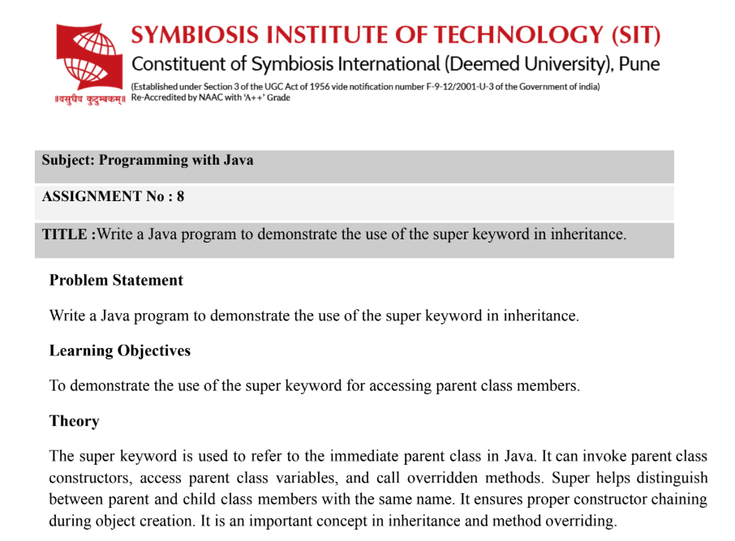
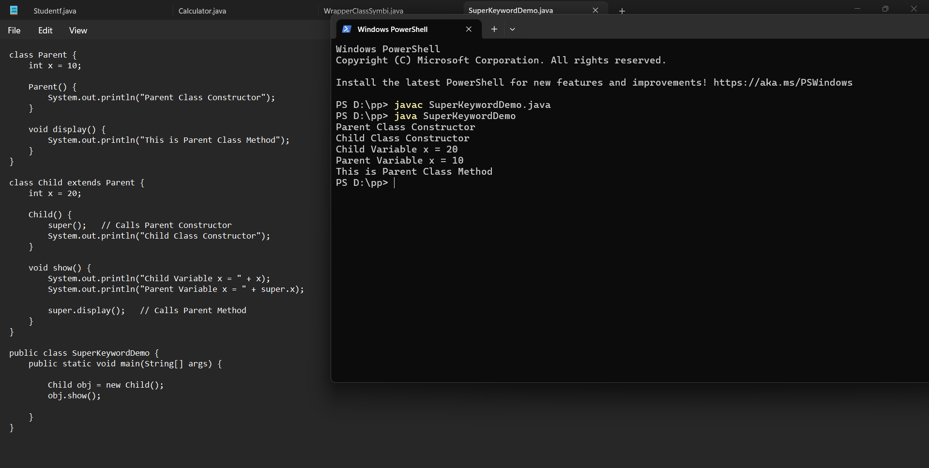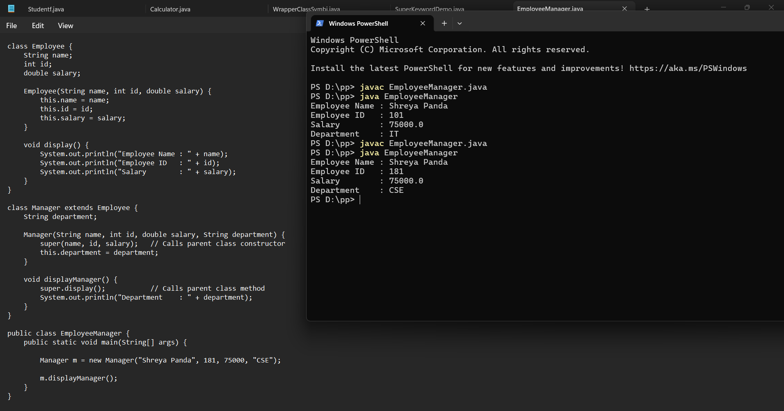
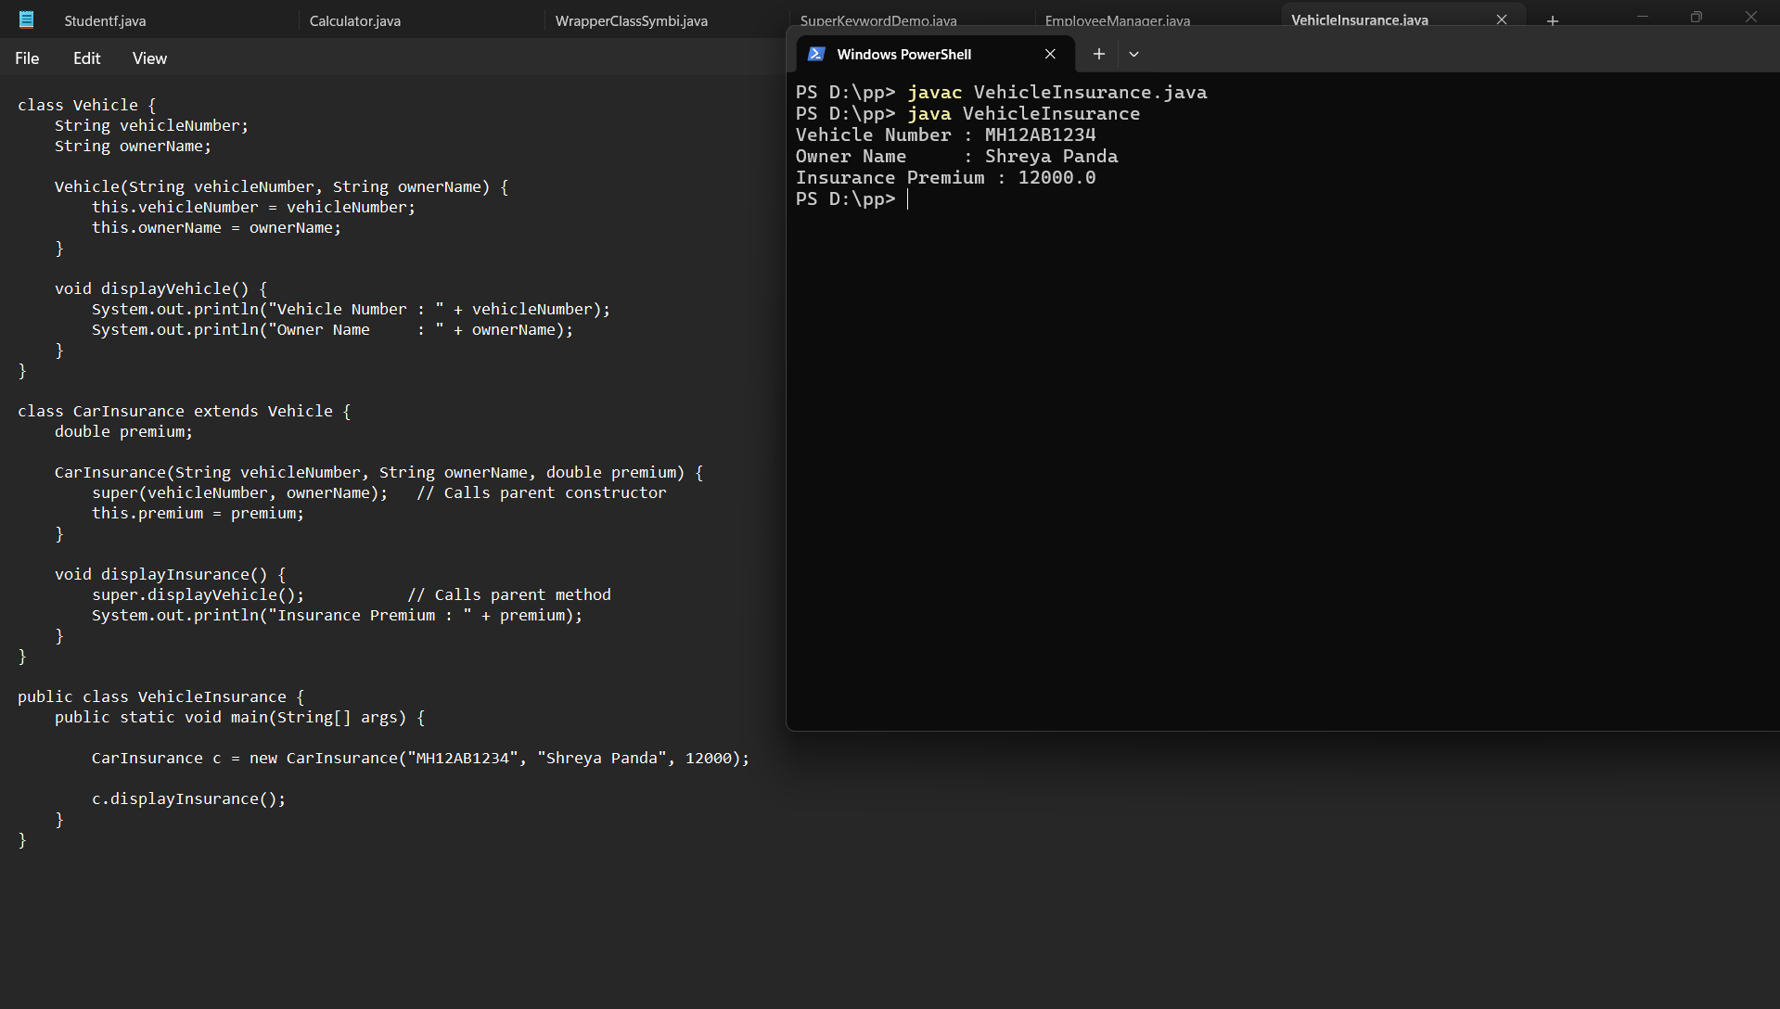
Conclusion
This assignment demonstrated the use of the super keyword in Java inheritance. It showed how super can be used to access parent class constructors, variables, and methods, ensuring proper initialization and code reuse. The implementation highlighted the relationship between parent and child classes, making object-oriented programming more organized, efficient, and easier to maintain.

